build a fully local/personal version of this without needing your company's KFUSE/Jira/ArgoCD infrastructure.
I would actually build the first version as a local incident → RCA → proposed fix → alert system, then progressively add autonomous code changes.

1. What you are building
Your personal setup can look like this: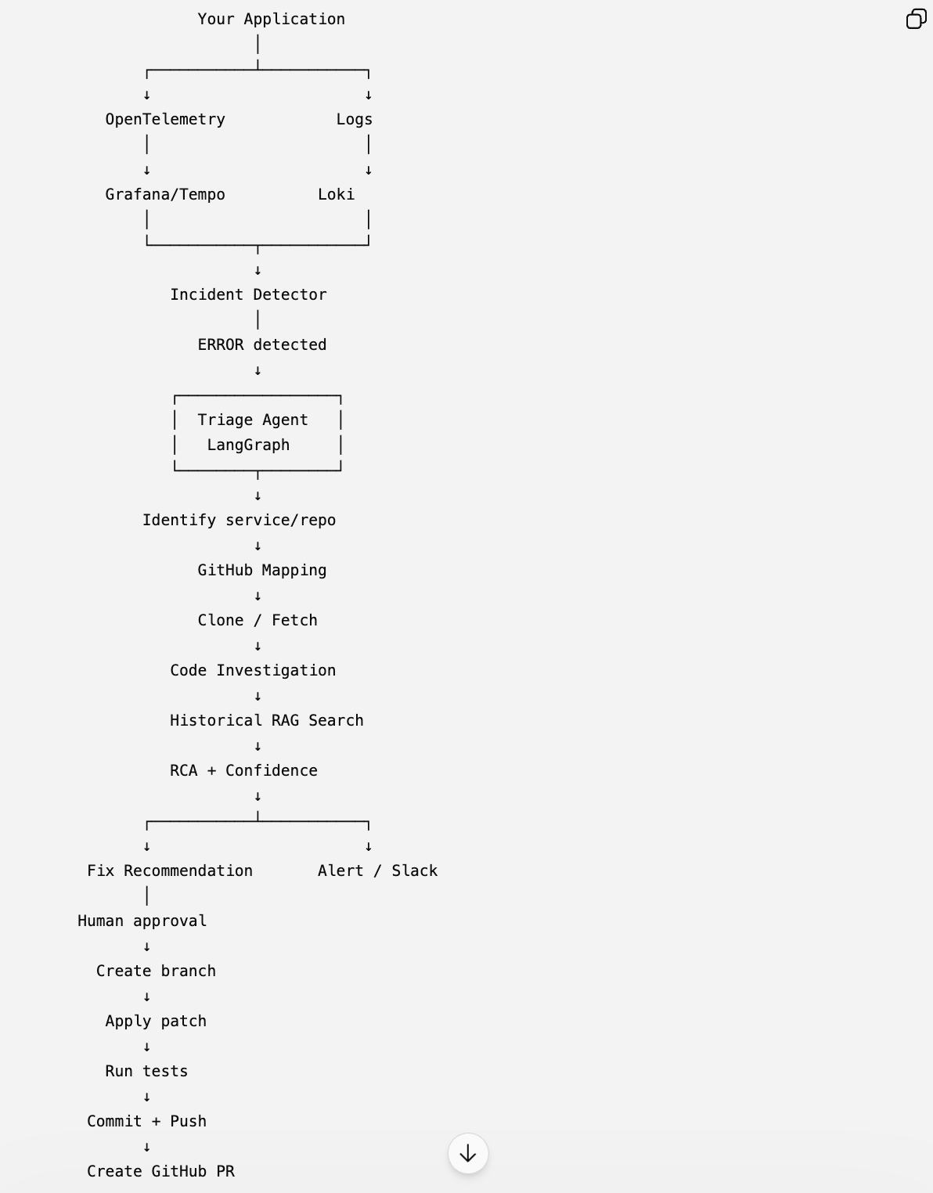

This is a very good portfolio project because it demonstrates actual agentic engineering rather than just a chatbot.

2. Don't start with KFUSE
For your personal implementation, I would not try to reproduce KFUSE first.
Use open-source observability:

Logs
Grafana Loki

Metrics
Prometheus

Traces/APM
OpenTelemetry + Grafana Tempo

Visualization
Grafana
You essentially get:
Application
│
├── logs ──────────→ Loki
│
├── metrics ───────→ Prometheus
│
└── traces ────────→ Tempo

Grafana
↑
Human investigation
Your AI agent independently queries those systems.
Later, if you have access to KFUSE, replace your LokiTool / TempoTool with KFUSETool.

3. Recommended personal tech stack
I'd use:
Component | Tool
Application | Python/FastAPI
Logs | Loki
APM/tracing | OpenTelemetry
Trace backend | Tempo
Metrics | Prometheus
Dashboard | Grafana
Agent | LangGraph
LLM | OpenAI API / Claude API
Structured output | Pydantic
RAG | pgvector
Database | PostgreSQL
Cache/state | Redis
Git | GitHub
Code search | ripgrep/tree-sitter initially
GitHub integration | GitHub API
Alerts | Slack webhook
Containers | Docker Compose
Tests | Pytest
Agent observability | LangSmith / OpenTelemetry
You could run almost everything except the LLM locally.

4. Your local project structure
I'd create two repositories initially.

Repo 1 — application
demo-payment-service/
├── app/
│ ├── main.py
│ ├── api.py
│ └── services/
├── tests/
├── Dockerfile
└── docker-compose.yml
This application intentionally contains bugs.
For example:
@app.get("/payments/{payment_id}")
def get_payment(payment_id: str):
logger.info(f"Fetching payment {payment_id}")

payment = db.get_payment(payment_id)

if payment is None:
logger.error(
f"Payment not found: {payment_id}"
)
raise HTTPException(404)

return payment
Later you introduce:
logger.error(...)
or:
raise Exception(...)
to trigger your agent.

5. Repo 2 — incident agent
incident-triage-agent/
│
├── app/
│ ├── main.py
│ │
│ ├── agents/
│ │ ├── graph.py
│ │ ├── incident_agent.py
│ │ ├── rca_agent.py
│ │ └── fix_agent.py
│ │
│ ├── tools/
│ │ ├── loki.py
│ │ ├── tempo.py
│ │ ├── prometheus.py
│ │ ├── github.py
│ │ ├── code_search.py
│ │ ├── git.py
│ │ └── slack.py
│ │
│ ├── models/
│ │ ├── incident.py
│ │ ├── rca.py
│ │ └── fix.py
│ │
│ ├── services/
│ │ ├── incident_detector.py
│ │ ├── repo_mapper.py
│ │ └── notification.py
│ │
│ └── config.py
│
├── knowledge/
│ ├── incidents/
│ └── runbooks/
│
├── tests/
│
├── Dockerfile
├── docker-compose.yml
└── pyproject.toml
This separation is useful because eventually the agent can investigate multiple services.

6. Service → GitHub repository mapping
This is a very important part of your architecture.
Create something like:
services:
payment-service:
repository: github.com/yourname/payment-service
branch: main
language: python
owner: payments

user-service:
repository: github.com/yourname/user-service
branch: main
language: python
owner: identity

order-service:
repository: github.com/yourname/order-service
branch: main
language: python
owner: commerce
Your agent receives:
ERROR
service=payment-service
Then:
payment-service
↓
service registry
↓
github.com/yourname/payment-service
No LLM is needed for this part.
Keep deterministic mappings deterministic.

7. Detecting errors
Your application emits:
{
"timestamp": "2026-09-24T10:30:21Z",
"level": "ERROR",
"service": "payment-service",
"message": "Database connection timeout",
"request_id": "req-123",
"trace_id": "abc123"
}
Loki stores it.
Your agent periodically queries:
level=ERROR
For example:
{service="payment-service"} |= "ERROR"
Your detector produces:
{
"incident_id": "INC-1001",
"service": "payment-service",
"severity": "P1",
"first_seen": "...",
"last_seen": "...",
"error_count": 37
}

8. Don't trigger an agent for every ERROR
This is critical.
Otherwise:
ERROR
ERROR
ERROR
ERROR
ERROR
will create five agent runs.
Instead implement incident aggregation.
For example:
Same service
+
Same error signature
+
5 minute window
+
> 5 occurrences
→ one incident.
So:
37 errors
↓
Incident INC-1001
This dramatically reduces LLM cost.

9. Incident classification
Your first LangGraph node:
Incident detected
↓
Classify
Output:
{
"service": "payment-service",
"type": "database",
"severity": "P1",
"symptom": "database timeout",
"request_id": "req-123"
}
Possible categories:
DATABASE
API
NETWORK
MEMORY
CPU
DEPENDENCY
DEPLOYMENT
APPLICATION
UNKNOWN

10. Then query logs
Your agent calls:
search_logs(
service="payment-service",
start_time="-10m",
end_time="now"
)
It might find:
Database connection timeout
Connection pool exhausted
Retry attempt 1
Retry attempt 2
Retry attempt 3
The LLM summarizes these.

11. Then investigate APM
This is where OpenTelemetry becomes powerful.
Your trace:
GET /payments/123
│
├── payment-service 7.8s
│
├── postgres 6.9s
│
└── redis 200ms
Agent sees:
Total latency: 7.8 sec
Postgres: 6.9 sec
Redis: 200 ms
Application: 700 ms
It can now say:
88% of request latency originates from PostgreSQL.
That's much stronger evidence than an LLM guessing from logs.

12. Then investigate GitHub
Now the agent calls:
get_recent_commits(
repository="payment-service",
since="24h"
)
Suppose:
Commit:
8a71d3

Author:
Amber

Changed:
payment_repository.py
Then:
git diff HEAD~1 HEAD
Agent gets:
- query = "SELECT * FROM payments WHERE id = ?"

+ query = """
+ SELECT *
+ FROM payments
+ WHERE customer_id = ?
+ ORDER BY created_at DESC
+ """
Now your agent has:
ERROR
↓
DB timeout
↓
APM shows DB = 6.9 sec
↓
Recent deployment
↓
Recent DB query change
That is a meaningful RCA chain.

13. Code investigation
Give the agent tools such as:
search_code()
read_file()
find_function()
find_references()
git_diff()
run_tests()
For example:
search_code("customer_id")
Then:
payment_repository.py
payment_service.py
payment_controller.py
The agent can trace:
API
↓
Controller
↓
Service
↓
Repository
↓
SQL

14. Add RAG
Now introduce historical knowledge.
Store:
knowledge/
incidents/
INC-001.md
INC-002.md
INC-003.md

runbooks/
database-timeout.md
redis-timeout.md
high-memory.md
Eventually put these in:
Postgres
+
pgvector
Your retrieval:
"payment service postgres timeout"
might retrieve:
INC-004
Postgres connection pool exhaustion

INC-019
Slow payment query

runbook:
Database timeout troubleshooting
The agent gets additional context.

15. RCA agent
Now LangGraph reaches:
RCA Agent
Give it evidence:
{
"logs": [...],
"traces": [...],
"metrics": [...],
"deployments": [...],
"code_changes": [...],
"similar_incidents": [...]
}
Require structured output:
class RCA(BaseModel):
root_cause: str
confidence: float
evidence: list[str]
affected_component: str
recommended_action: str
Example:
{
"root_cause": "Database query regression",
"confidence": 0.91,
"affected_component": "payment_repository.py",
"evidence": [
"Postgres accounts for 88% of request latency",
"Error rate increased after deployment",
"Recent commit modified payment query",
"Similar historical incident involved the same query"
],
"recommended_action": "Review query plan and restore missing index"
}

16. Now the interesting part: automatically fixing code
Don't immediately let the agent push directly to main.
Use:
main
│
└── agent/INC-1001
The agent modifies the branch.
For example:
incident
↓
create branch
↓
modify code
↓
run tests
↓
run lint
↓
run application
↓
verify
↓
commit
↓
push
↓
create PR
The human reviews the PR.
This is much safer and also demonstrates strong engineering practice.

17. Fix Agent
Give the LLM a very constrained tool:
create_patch()
not:
execute_any_shell_command()
The workflow:
RCA
↓
Fix hypothesis
↓
Generate patch
↓
Apply patch
↓
Run tests
↓
Tests pass?
│
┌──┴──┐
No Yes
↓ ↓
Retry Create PR
Limit retries:
max_attempts = 2 or 3

18. Alert
Use Slack.
Your agent sends:
🚨 P1 Incident Detected

Service:
payment-service

Error:
Database connection timeout

Occurrences:
37

APM:
Postgres = 6.9s / 7.8s

Recent deployment:
8a71d3

RCA:
Likely database query regression

Confidence:
91%

Recommended action:
Review missing index

🤖 Agent created:
PR #17

Status:
Awaiting human review

19. Your complete LangGraph
I'd make the graph approximately:
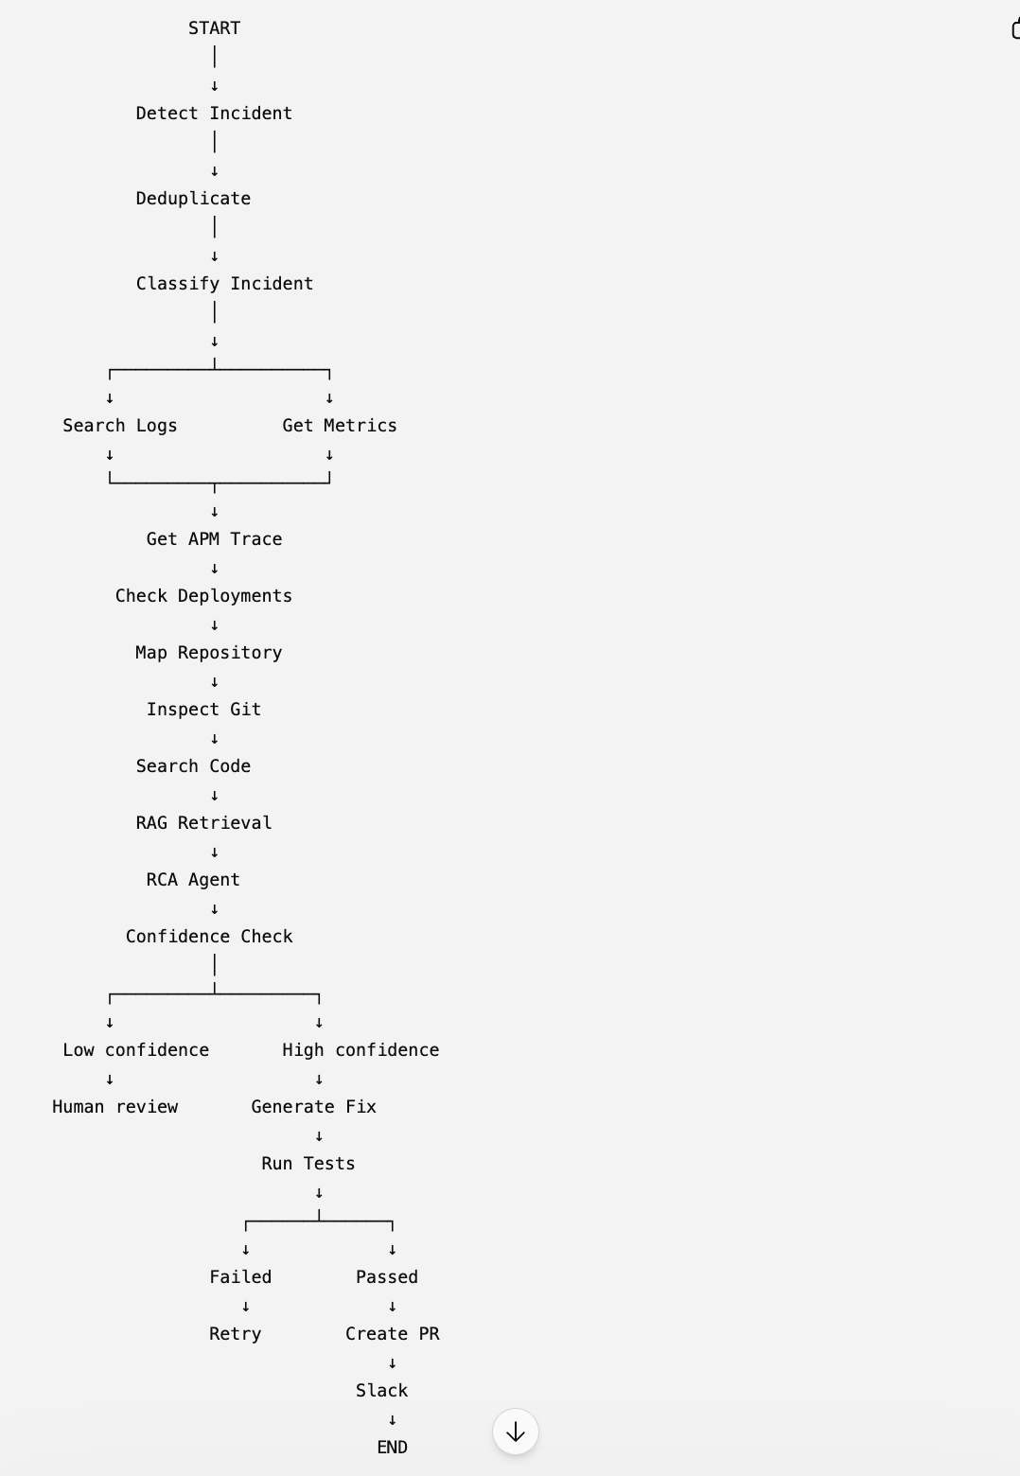
This is a real agentic workflow.

20. Local Docker Compose
Your initial infrastructure could be:
docker-compose

├── demo-service
├── incident-agent
├── postgres
├── redis
├── loki
├── tempo
├── prometheus
└── grafana
Then:
localhost:8000
↓
demo application

localhost:3000
↓
Grafana

localhost:3100
↓
Loki

localhost:3200
↓
Tempo

localhost:9090
↓
Prometheus

localhost:8001
↓
Incident Agent

21. The AI stack I'd actually use
For your portfolio implementation, I'd keep it relatively focused:
AI Layer

GPT-5.x / Claude
│
LangGraph
│
┌─────────┴─────────┐
│ │
Tool Calling RAG
│ │
┌──────┼──────┐ pgvector
│ │ │
Loki Tempo GitHub
│ │ │
└──────┼──────┘
│
Kubernetes
│
ArgoCD
You don't need 15 AI frameworks.
LangGraph + LLM + tool calling + RAG + structured outputs is enough.

22. What I would NOT add initially
Avoid these in V1:
- Multi-agent swarm
- Fine-tuning
- Complex vector databases
- Autonomous production deployment
- Kubernetes remediation
- 10 different LLM providers
- complicated memory systems
- elaborate MCP infrastructure
Build the fundamentals first.

23. V1 → V2 → V3

V1 — Local RCA
App
↓
Loki
↓
Agent
↓
Logs
↓
RCA
↓
Slack

V2 — Intelligent RCA
Logs
+
APM
+
Metrics
+
GitHub
+
RAG
↓
RCA

V3 — Autonomous Engineering
Incident
↓
RCA
↓
Code investigation
↓
Generate patch
↓
Tests
↓
Git branch
↓
GitHub PR
↓
Slack
↓
Human approval

V4 — Production-grade
P0/P1 detection
+
incident correlation
+
historical learning
+
evaluation
+
agent observability
+
controlled remediation

One important change to your original idea
Don't design it as:
ERROR → LLM → clone repo → fix
Design it as:
Signal → Correlation → Investigation → Evidence → RCA → Fix hypothesis → Validation → Human-approved action
That distinction is what makes this an AI-powered production engineering platform rather than an LLM script.

